CaMKII:PP1 40:1 10:1 4:1

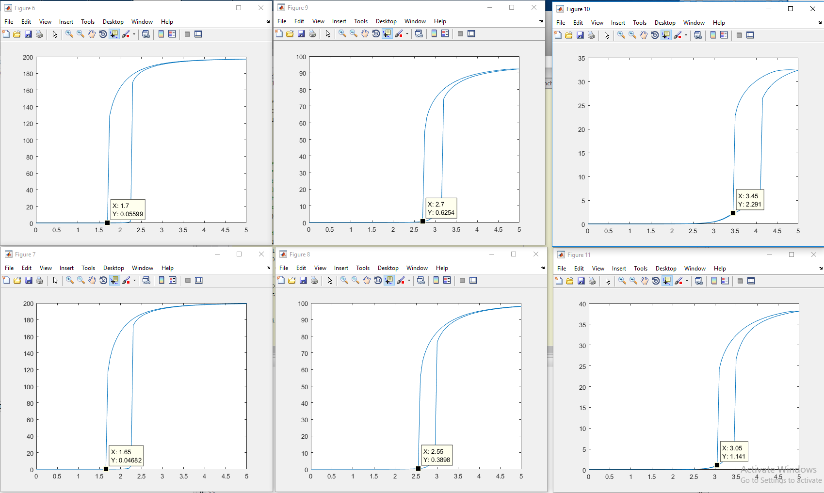

A – Model Creation and Validation

The model in Zhabotinsky, 2000 was replicated and modified to include two additional features: (1) support for dodecamer and tetradecamer CaMKII structure and (2) geometric exclusion of PP1 from interaction with a CaMKII subunit that is in complex with CaM4. Which were then (3) validated against panel 9A.

(1) To introduce more complex CaMKII structure, the basic equations used to determine rate modifying coefficients were altered slightly. Zhabontinsky et al. utilize a model of unidirectional (clockwise) asymmetric phosphorylation by neighboring subunits in a single ring. In the absence of a phosphatase, this would produce only a single configuration for each given number of phosphorylated subunits of CaMKII. However, phosphatase activity operates at random, and as such all unique configurations of phosphorylated/non-phosphorylated exist with roughly equal probabilities. As such, the average number of neighboring subunits for each phosphorylation state can be determined from his equation 10:

$$w_{i}=w_{N-i}= \sum_{j = 1}^{i}{\frac{j\left(\begin{matrix}\frac{N}{2} \\ j\end{matrix}\right)}{\left(\begin{matrix}\frac{N}{2} \\ j\end{matrix}\right)}}$$

where *i* is the number of phosphorylated subunits of CaMKII with *i* autophosphorylating pairs, and N is the total number of subunits (10, 12, or 14). The model takes N as an input and produces N+1 differential equations for phosphorylation states ranging from 0 phosphorylated subunits, P0, to PN. Scaling the constant catalysis rate of single neighboring pairs appropriately for each phosphorylation state by these coefficients.

(2) In this model, Zhabotinsky et al. similarly assume that the phosphorylation state has no effect or influence on binding or unbinding of CaM4 in complex with a subunit. As such, the fraction of phosphorylated subunits and unphosphorylated subunits in complex with CaM4 are equal, and can be determined using the calcium Hill constant as in equation 5:

$$F= \frac{{\left(\frac{\left[{Ca}^{2+}\right]}{K_{H1}}\right)}^{4}}{1+ {\left(\frac{\left[{Ca}^{2+}\right]}{K_{H1}}\right)}^{4}}$$

where KH1 = [Ca2+]50 is the calcium Hill constant for CaMKII. To introduce geometric exclusion of PP1 by CaM4, the number of available phosphorylated subunits was scaled down by a factor of (1 – *F)*.

(3) To validate this model the conditions used to produce panel 9A were input and the model used to reproduce this panel using the decameric CaMKII model without the addition of the exclusion rule in (2).

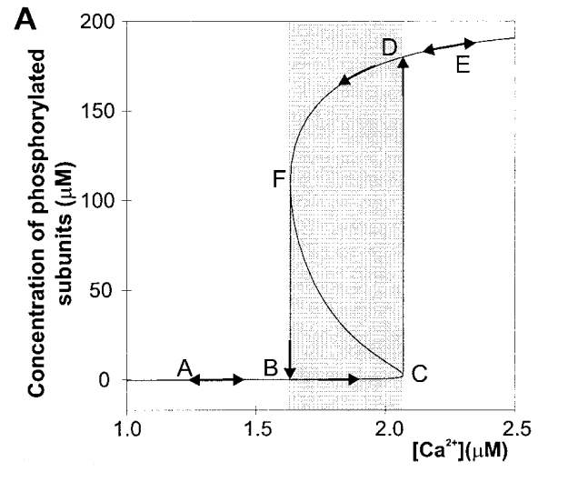

**Fig 1.** (Left) Panel 9A from Zhab. 2000 of duty cycle plot of bistability during a [Ca2+] sweep (Right) replicated duty cycle plot using updated model, note similar thresholds of bistability and autophosphorylation threshold behavior.

B – Geometric Exclusion of PP1 by CaM4

This simulation was then repeated with the introduction of the exclusion rule. As seen in figure two the model response was a reduction in the [Ca2+] thresholds of bistability. This is indicative of a slightly higher observable activity of CaMKII, requiring less Ca2+ to produce similar phosphorylation behavior. This is logical behavior given the reduction in antagonistic phosphatase activity by the introduction of CaM4 competitive binding inhibition.

**Fig 2.** Conditions from figure 1 repeated with CaM4 comp. binding

This analysis was then repeated using the decamer model to sweep a range of CaMKII:PP1 activities modeled via both concentration changes and catalytic rate changes.



 

 

**Fig 3.** (Top Left) Overlay of Non-Ruled and Ruled model under standard conditions. (Top Right) Plots are nearly congruent under high CaMKII:PP1 activity ratio conditions. (Center Left) When CaMKII activity is held constant and the activity of PP1 increases, a greater shift is observed in the ruled and non-ruled models. (Center Right) Similarly, when CaMKII activity is decreased in the presence of consistent PP1 activity, the shift is more significant than at higher activity ratios. This is indicative of more robust retention of bistable behavior as a function of relative activity of these two agonists. In each case, the ruled model remains truer to the traditional patterning of the calcium duty cycle and demands lower calcium thresholds for bistability. (Bottom Left) Overlay plot of two central frames. (Bottom Right) In the case of modification of both parameters, the magnitude of the shift between the ruled and non-ruled models is amplified and more overall changes in the duty cycle patterning (congruency of the curves) are observed between states.